**Project Title: Customer 360 & Loyalty Initiative – E-Commerce Retention & Personalization System**

**Industry: E-Commerce (B2C)**

**Project Type: Salesforce Sales Cloud, Service Cloud, and Marketing Cloud Implementation**

**Target Users: Customer Support Agents, Marketing Managers, Sales Managers, Customers**

**1. Problem Statement**

A leading e-commerce company faces critical challenges in customer retention and operational efficiency. Despite having a large customer base, the company struggles with:

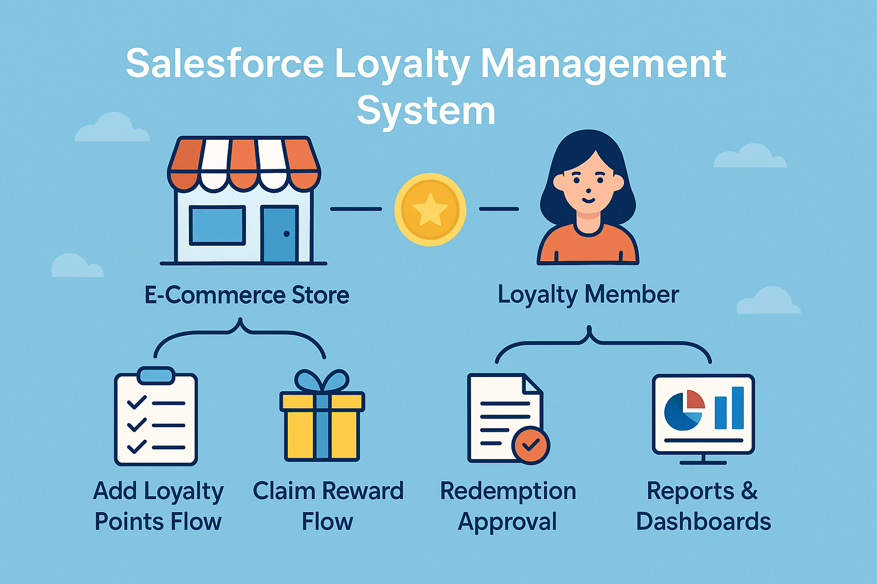

* **Fragmented Customer Data:** Customer information is scattered across multiple systems (website, support emails, WhatsApp, order management), making it impossible to get a complete view of any customer.
* **Slow Customer Support:** Support agents waste valuable time switching between applications to find customer information, leading to delayed response times and frustrated customers.
* **Ineffective Marketing:** Generic, one-size-fits-all marketing campaigns are sent to all customers, resulting in irrelevant offers that irritate high-value customers and miss engagement opportunities.
* **No Loyalty Recognition:** The company cannot identify or reward loyal customers, treating one-time buyers the same as repeat customers, missing opportunities to increase customer lifetime value.
* **Lack of Business Insights:** Management has no real-time visibility into customer behavior, agent performance, or customer health scores, making data-driven decisions impossible.

**Business Impact:** This results in declining customer satisfaction scores, low repeat purchase rates, increased customer churn, and significant revenue loss.

**2. Solution Overview**

Implement a unified Salesforce CRM platform to transform customer engagement through:

**Centralized Customer Data**

* Create a 360-degree view of every customer by integrating purchase history, support interactions, and communication preferences into a single Salesforce dashboard.

**Intelligent Customer Support**

* Implement Service Cloud with omnichannel routing to automatically assign cases via email, chat, and WhatsApp to the most appropriate agent based on skills and workload.

**Personalized Marketing Automation**

* Use Marketing Cloud to create dynamic customer segments and trigger personalized campaigns based on individual behavior, purchase history, and preferences.

**Loyalty Program Management**

* Build a custom loyalty system where customers earn points for purchases and engagements, with automated tier upgrades and personalized rewards.

**Real-Time Business Intelligence**

* Develop comprehensive dashboards showing customer health scores, agent performance metrics, and predictive churn analysis using Einstein Analytics.

**3. Key Use Cases**

**Use Case 1: Unified Customer Profile**

* **Scenario:** A customer contacts support about a delayed order
* **Solution:** Agent sees complete history: past orders, previous support cases, loyalty points, and recent website activity in one screen
* **Result:** 50% faster resolution time, personalized service experience

**Use Case 2: Smart Case Routing**

* **Scenario:** Customer sends WhatsApp message about product return
* **Solution:** System automatically routes to returns specialist based on product category and agent availability
* **Result:** Reduced handling time from 24 hours to 2 hours

**Use Case 3: Personalized Marketing**

* **Scenario:** Customer abandons cart with running shoes
* **Solution:** Automated journey sends personalized email with shoe recommendations + matching socks offer
* **Result:** 35% higher conversion rate vs. generic blasts

**Use Case 4: Loyalty Automation**

* **Scenario:** Customer makes third purchase totaling ₹15,000
* **Solution:** System automatically upgrades to Gold tier, grants early access to upcoming sale
* **Result:** 40% increase in repeat purchase frequency

**Use Case 5: Management Dashboard**

* **Scenario:** VP of Sales needs weekly performance metrics
* **Solution:** Real-time dashboard shows customer lifetime value, churn risk, agent productivity
* **Result:** Data-driven decision making, proactive customer retention

**4. Technical Components**

**Salesforce Products Used:**

* **Sales Cloud:** Account/Contact management, Opportunity tracking
* **Service Cloud:** Case management, Omnichannel routing, Service console
* **Marketing Cloud:** Customer journeys, Email studio, Personalization
* **Platform:** Custom objects, Apex automation, Lightning components

**Custom Development:**

* **Loyalty_Member__c object:** Points balance, tier status, member since
* **CLVCalculator:** Batch Apex for customer lifetime value calculation
* **Loyalty Points Flow:** Automated points allocation on order completion
* **Customer 360 Console:** Custom Lightning interface for support agents

**5. Business Benefits**

| Metric | Before | After | Improvement |
| --- | --- | --- | --- |
| Customer Response Time | 24+ hours | < 2 hours | 92% faster |
| Repeat Purchase Rate | 15% | 35% | 133% increase |
| Customer Satisfaction | 3.2/5 | 4.5/5 | 41% improvement |
| Marketing Conversion | 2% | 5% | 150% increase |
| Customer Retention | 60% | 85% | 42% improvement |

**ROI:** Projected payback period: 12 months  
**Annual Revenue Impact:** ₹2.5 crore incremental revenue